The increased competition for the scarce natural resource has led to challenges of formidable water management in many countries in the world. One of the most considerable constraints on sustainable agricultural development is the overexploiting of water resources thereby making it an essential factor to the alleviation of poverty. There has been a recognition of water as an essential component of food security [1], with more attention being drawn on the significance of management of water by the World Summit on Sustainable Development in 2002, in an attempt to meet the Millennium Development Goals (MDGs) [2].

The intensified agriculture, forestry and game reserves attracting tourists from all over the world has led to a high economic status in the Ewaso Ngiro Basin, offering a great deal of beautiful scenery. Accordingly, there is prioritization of careful management and negotiation of water resources to curb the increasing water crises and conflicts at both levels, local and national. Despite much research being carried out in the basin on aspects of water resources, Mt. Kenya area, which is the main contributor of the Ewaso Ngiro river has been much focused on, unlike the downstream catchments [3][4]. However, in recent years, there has been an experience of water crises to a previously unknown extent in lower catchments [3].

**Introduction to LoRa**

“Long Range,” initiated by LoRa, is a wireless communication system that is of long-range, promoted by the LoRa Alliance. The aim of this system is to be used in long-lived battery-powered devices, where the use of energy consumption is of utmost significance. LoRa modulation is a proprietary spread spectrum method grounded on chirp spread spectrum modulation that uses wideband linear frequency modulated pulses. Furthermore, LoRa can usually refer to two distinct layers, that is, a physical layer using the Chirp Spread Spectrum (CSS) [5] [6]radio modulation technique, and a Media Access Control (MAC) Layer protocol LoRa-Wide Area Network (LoRaWAN).

LoRa parameters available for customization of the LoRa modulation include the Bandwidth (BW), the Spreading Factor (SF), and the Code Rate (CR) [7]. The bandwidth is depended on by the chirp rate, which is equal to the bandwidth (one chirp per second per Hertz of bandwidth). Also, the symbol rate and bit rate are proportional to the frequency bandwidth at a given spreading factor; hence, a bandwidth doubling will effectively double the rate of transmission [8]. An increase of bandwidth lowers receiver sensitivity, while an increase of the spreading factor increases the sensitivity of the receiver.

**RESULTS**  
LoRa Coverage at Ol-Pejeta

**Table 1:** The Lorix One and Kerlink LoRa Gateways Specifications and Operations (subject to environmental factors and placement of nodes/sensors and gateways) taken from [9][10]

|  |  |  |
| --- | --- | --- |
|  | **LORIX ONE** | **KERLINK LORA** |
| Antenna | Indoor 20cm Inclinable Antenna, 2dBi, 27dBm max output | Indoor 20cm Inclinable Antenna, 2dBi, 28dBm max output |
| Receiver Sensitivity | -140dBm | -141dBm |
| Operating Temperature | Min: -30 °C; Max: +55 ℃ | Min: -20 °C; Max: +55 ℃ |
| Communicating Range | Line of sight(*Antenna): +10kms  Urban: up to 1km | Line of sight(*Antenna): +15kms  Urban: up to 2kms |
| Installation | Wall or Pole mounting  Metallic Strapping | Wall or Pole mounting  Metallic Strapping |

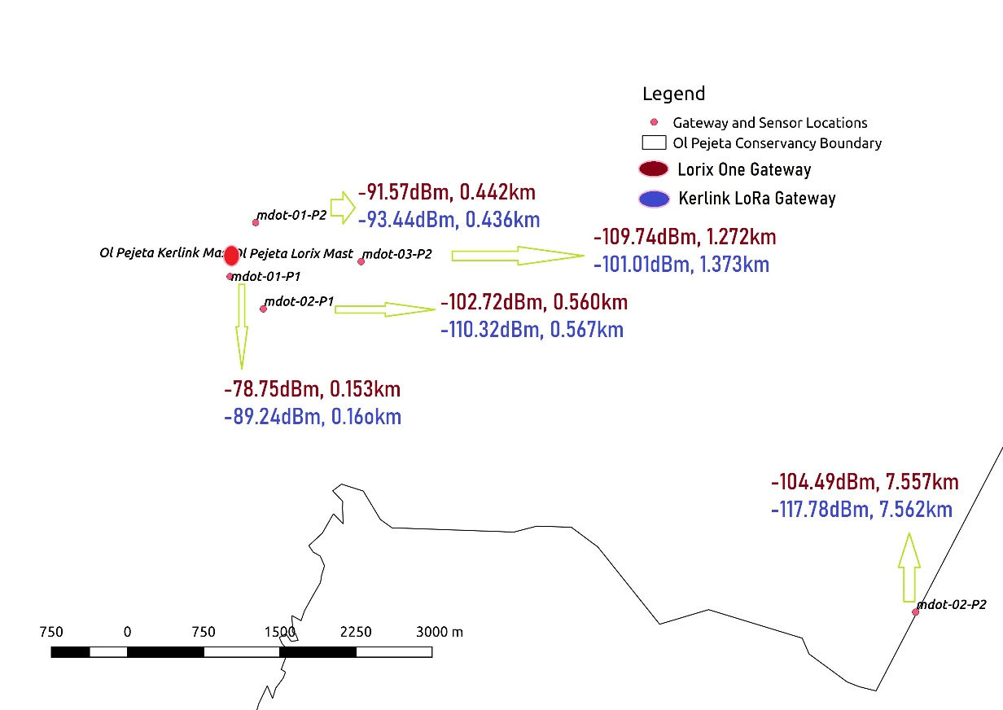

**Figure:** Test Points Geographical Locations/Distances from the Gateways and the obtained RSSs

**The Received Signal Strength Indication (RSSI)**

This refers to the signal power that is received in Milliwatts, and it is measured in dBm. How clear a receiver can “hear” from a sender can be measured using this value. Received signal strength indication, i.e., RSSI, is usually a negative value; hence, the signal is better when it is more positive (closer to 0). The value ranges of typical LoRa RSSI is -140 dBm to -30dBm.

For our experiments, we computed the mean RSSI for each of the 5 test locations that were used. At approximately 150m away from the gateway, the LORIX One gateway outperformed the Kerlink gateway by a margin of 10dBm as well as at the furthest distance (approximately 7.5km) by 13dBm dBm. The best strength was realized at the nearest test location while it notable that this value decrease (worsens) as we moved to test locations far away from the gateway, as depicted by **Table 2.**  **Table *2*:** The *Mean RSSI (in dBm) for the Five (5*) Test Locations *for each Gateway*

|  |  |  |  |  |
| --- | --- | --- | --- | --- |
|  | **LORIX One Gateway** | | **Kerlink LoRa Gateway** | |
| **Distance(km)** | **RSSI(dBm)** | **Distance(km)** | **RSSI(dBm)** |
| **1** | 0.152 | -78.75 | 0.160 | -89.24 |
| **2** | 0.442 | -91.57 | 0.436 | -93.44 |
| **3** | 0.560 | -102.72 | 0.567 | -110.32 |
| **4** | 1.272 | -109.74 | 1.273 | -101.01 |
| **5** | 7.557 | -104.49 | 7.562 | -117.78 |

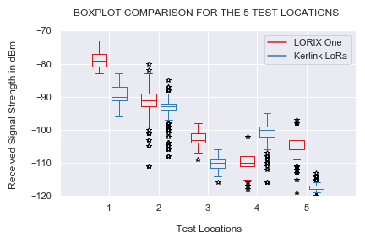

**Figure** : The Received Strength Whisker and Box Plots for the 10 Test Locations.

The Whisker and Box Plots in **Figure**  provides a quick graphical examination of the RSSI for each of five(5) test locations for each gateway. Outlier RSSIs were highly realized in test location 2 and they are plotted as individual points, while none were realized at location 1 (nearest to the gateways). However, location 1 depicts the highest notable degree of dispersion (spread) and skewness for both gateways. There is a general non-linear variation of the median positions of the RSSI, usually determined by various parameters, which include free space loss, shadowing, reflection and transmission, diffraction, among others.

[1] Unesco, “Facts and Figures from the United Nations World Water Development Report 4,” p. 16, 2012.

[2] UNDESA, “The Millennium Development Goals Report 2005,” *United Nations*, p. 48, 2005.

[3] “River Water Shortage in a Highland – Lowland System,” vol. 25, no. 2, pp. 155–162, 2019.

[4] B. Notter, L. MacMillan, D. Viviroli, R. Weingartner, and H. P. Liniger, “Impacts of environmental change on water resources in the Mt. Kenya region,” *J. Hydrol.*, vol. 343, no. 3–4, pp. 266–278, 2007.

[5] A. J. Bern and W. D. Gregg, “On the,” no. June, pp. 748–751, 1973.

[6] A. Springer, W. Gugler, M. Huemer, L. Reindl, C. C. W. Ruppel, and R. Weigel, “Spread spectrum communications using chirp signals,” *IEEE/AFCEA - EUROCOMM 2000 Inf. Syst. Enhanc. Public Saf. Secur.*, vol. 00, no. 6, pp. 166–170, 2000.

[7] A. Augustin, J. Yi, T. Clausen, and W. M. Townsley, “A study of Lora: Long range & low power networks for the internet of things,” *Sensors (Switzerland)*, vol. 16, no. 9, pp. 1–18, 2016.

[8] B. Sikken, “DecodingLora - RevSpace.” 2017.

[9] “Easy to use and low cost LoRa _ LoRaWAN IoT gateway _ LORIX One.” .

[10] “Kerlink LoRa IoT Gateway - Wirnet Station 868 MHz.” .